1. **Classifier integration model (CIM)**

* The classifier integration model utilizes the confusion matrix values as a weight value for constituent classifier models.
* For each data x applied to CIM, each local classifier produces the probability that the data x belongs to the class j, Cj , as follows



* where represents the probability that the classifier k, classifies the data as Class j when the data is from of Class i and M denotes the number of classes.
*  is the probability that the classifier k classifies the data as Class j
* (the probability is calculated for each class, vertically)

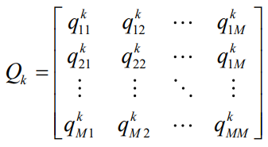

* the classifier yields a probability that the data x belongs to the class j, Cj , as follows



1. **Classifier integration model (CIM) for Diabetes dataset**

* we generated three distinct (ensembled) classifiers for each class (Diabetes, Prediabetes, Normal)

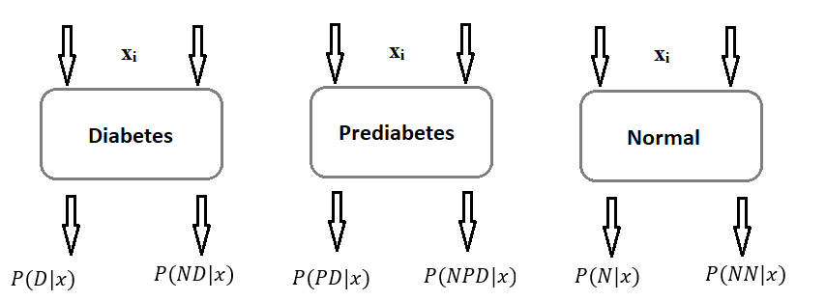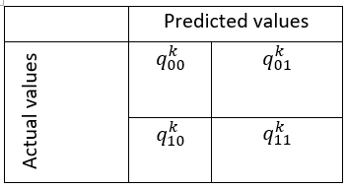


* +
* + [N: normal, NN: not normal, D: diabetes, ND: note diabetes, PD: prediabetes, NPD: not prediabetes]
  1. **Experimental results**
     1. **Diabetes dataset**
        + Baseline classifier: [RF], accuracy= 0.70
        + Voting classifier: soft voting using
          - RF=0.70, SVM=0.72, XGBoost=0.72
          - Overall accuracy=0.715, all classifier are assigned equal weight=1,
        + CIM (using all classes): accuracy=0.68
        + CIM (using single classes): accuracy=0.71
        + Modified CIM: in this section the probability of a given data point belonging to a certain class is modified as follows:
          - _p_k1_c0 = _mainacc[0]*p_k1_c0 + (p_k2_c1 * p_k3_c1)
          - _p_k2_c0 = _mainacc[1]*p_k2_c0 + (p_k1_c1 * p_k3_c1)
          - _p_k3_c0 = _mainacc[2]*p_k3_c0 + (p_k2_c1 * p_k1_c1)
          - Overall accuracy: 0.73
     2. **Wine dataset**
        + Baseline classifier: accuracy = 0.94
        + CIM: accuracy = 0.98
     3. **Wine dataset**
        + Baseline classifier: accuracy = 0. 936
        + CIM: accuracy = 0.92
  2. Genetic algorithm-based weight optimization for classifier models

In this section we used genetic algorithm to find appropriate weight values for each constituent models of the ensemble classifier, with the assumption that the most accurate model will have higher weight value than the low performing models.

* + 1. Diabetes dataset experiments
       - 3 class ensemble approach
         * Baseline classifier: [RF], accuracy 0.68 [0.67 ± 0.015]
         * Using GA: accuracy = 0.735 [ cv score 0.73 ± 0.003] [0.78 ± 0.005]
         * Using Voting classifier = 0.735 [ cv score 0.76 ± 0.03]
       - Single class ensemble approach
         * Baseline classifier: [RF], accuracy 0.68 [cv 0.70 ± 0.005]
         * Using GA:

trial1_scores f1_score 0.70 [cv 0.70 ± 0.005] [cv 0.79 ± 0.006]

trial2_scores f1_score 0.71 [cv 0.71 ± 0.006] [cv 0.79 ± 0.005]

trial3_scores f1_score 0.70 [cv 0.71 ± 0.006] [cv 0.79 ± 0.005]

trial4_scores f1_score 0.48 [cv 0.71 ± 0.005] [cv 0.80 ± 0.004]

trial5_scores f1_score 0.71 [cv 0.43 ± 0.098] [cv 0.44 ± 0.138]

trial6_scores f1_score 0.71 [cv 0.72 ± 0.006] [cv 0.79 ± 0.006

* + 1. seed dataset experiments
       - 3 class ensemble approach
         * Baseline classifier: [RF], accuracy 0.95 [0.91± 0.084]
         * Using GA: accuracy = 0.95 [ cv score 0.93 ± 0.064]
         * Using Voting classifier = 0.96 [ cv score 0.94 ± 0.025]
       - Single class ensemble approach
         * Baseline classifier: [RF], accuracy 0.95 [0.92 ± 0.064]
         * Using GA:

trial1_scores f1_score 0.95 [cv 0.93 ± 0.005]

trial2_scores f1_score 0.95 [cv 0. 93 ± 0.006]

trial3_scores f1_score 0.95 [cv 0. 93 ± 0.006]

trial4_scores f1_score 0.84 [cv 0.83 ± 0.005]

trial5_scores f1_score 0.95 [cv 0.94 ± 0.098]

trial6_scores f1_score 0.95 [cv 0.94 ± 0.069]

* + 1. wine dataset experiments
       - 3 class ensemble approach
         * Baseline classifier: [RF], accuracy 0.94 [0.97± 0.037]
         * Using GA: accuracy = 0.98 [ cv score 0.97 ± 0.037]
         * Using Voting classifier = 0.96 [ cv score 0.96 ± 0.0368]
       - Single class ensemble approach
         * Baseline classifier: [RF], accuracy 0.94 [0.98 ± 0. 021]
         * Using GA:

trial1_scores f1_score 0.96 [cv 0.98 ± 0. 021]

trial2_scores f1_score 0.96 [cv 0. 98 ± 0. 021]

trial3_scores f1_score 0.96 [cv 0. 98 ± 0.021]

trial4_scores f1_score 0.69 [cv 0.90 ± 0.074]

trial5_scores f1_score 0.98 [cv 0.99 ± 0.016]

trial6_scores f1_score 0.96 [cv 0.99 ± 0.016]

1. Feature importance from Random forest

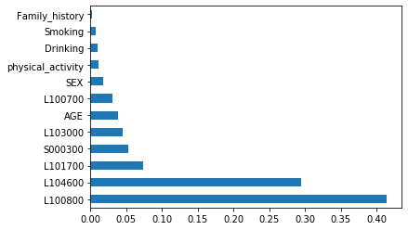

1. Histogram plot of HbA1C, AGE

